ACCREDITATION FORM FOR MEDIA
- 1st WTF World Taekwondo Beach Championships

Rhodes Island, 5-6 May 2017

PLEASE, RETURN ΤΗIS ACCREDITATION FORM ΒΥ APRIL 2017
Please, do not forget to attach your Photo

email: mediaetu@gmail.com

First /Middle Name
Family Name
Email
Nationality
Number of contact
Media
Media contacts
AIPS Card Number
Passport Number
Journalist….Photographer…..Blogger..…TV…. Radio…. Technician….*
*Tick √ on your preference.

Signature/ Date

NOTICE: Please write your name as appeared on Passport or other official credentials

ARRIVAL - DEPARTURE FORM FOR MEDIA

1st WTF World Taekwondo Beach Championships

Rhode Islands, Greece, 5-6 May 2017

PLEASE, RETURN ΤΗIS ARRIVAL - DEPARTURE FORM ΒΥ MAY 1, 2017.

e-mail: mediaetu@gmail.com
wtfbeach@taekwondoetu.org

First /Middle Name
Family Name
Email
Date of arrival
Flight number
Date of departure
Flight number
Passport Number

Visa Applications
To facilitate visa entry requirements, please complete and stamp the attached Visa Request Sheet and send it with a copy of each delegation member’s passports to the Organizing Committee’s.
Visa application requests must be received no later than 20.4.2017; the email subject should be Organizing Committee - Visa Application. The full name, address and contact number (phone, Fax and EMAIL) of Greek embassy must be provided in this email wtfbeach@taekwondoetu.org always CC mediaetu@gmail.com
Signature/ Date

NOTICE: Please write your name as appeared on Passport or other official credentials

Rodos Palace is the Official Hotel
for the 1st WTF World Taekwondo Beach Championships Rhodes 2017

The finest luxury Hotel in Rhodes, Rodos Palace, is the Official Hotel for the 1st WTF World Taekwondo Beach Championships Rhodes 2017. During the 40 years of its glorious history, the Rodos Palace Resort Hotel and Convention Center has established a leading position in the Greek Hospitality Industry through a persistent policy of commitment to fine hospitality and of bracing an excellent reputation. In this 5 star hotel, you will enjoy every minute of our Greek “filoxenia”!

All the accommodation fees will be collected directly by the GEM Travel Rhodes.
Official Hotel website: http://www.rodos-palace.gr/

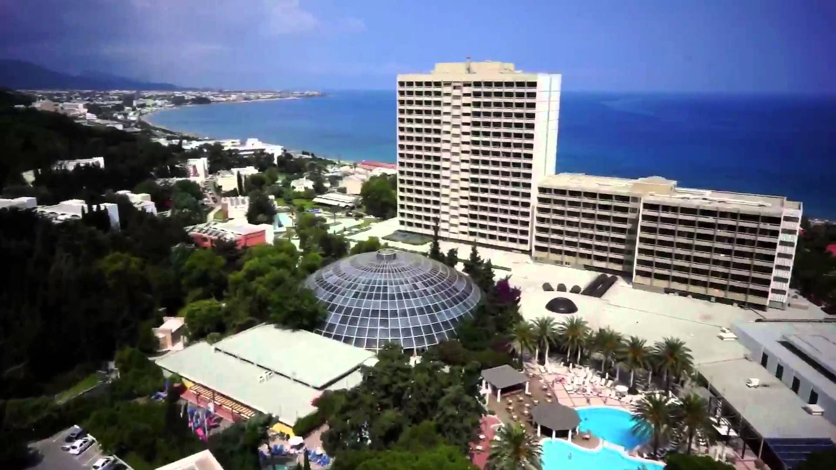

Book your reservation

The following pricings occur to more than one suggestion of hotel per category. Contact GEM Travel Rhodes and exploit a various hotel portfolio to the majestic centre or suburbs of Rhodes city.

- 5 star hotels All In: € 97 per person per day
- 5 star hotels HB: € 73 per person per day
- 4 star hotels All In: € 47 per person per day
- 4 star hotels HB: € 40 per person per day

- 4 star hotels BB: € 35 per person per day
- 3 star hotels HB: € 35 per person per day
- 3 star hotels BB: € 30 per person per day

NOTICE: For the 3-4-5 star hotels located in the North Region of the Island ( Ixia-Rhodes Town – Kallithea) Transport (Private ) 40€ per way ( up to 4 pax per route)

GEM Travel Rhodes

Avramios Pouliasis
Operation Manager
5TH km Rhodes-Lindos Avenue, 85100 Rhodes-Greece
Direct Line: +30 22410-84540
Fax : +30 22410-84583
Url: www.gemtravel.gr
Email: avramios@gemtravel.gr

More information about the
1st WTF World Taekwondo Beach Championships
will be delivered shortly with
the Media Guide release.

